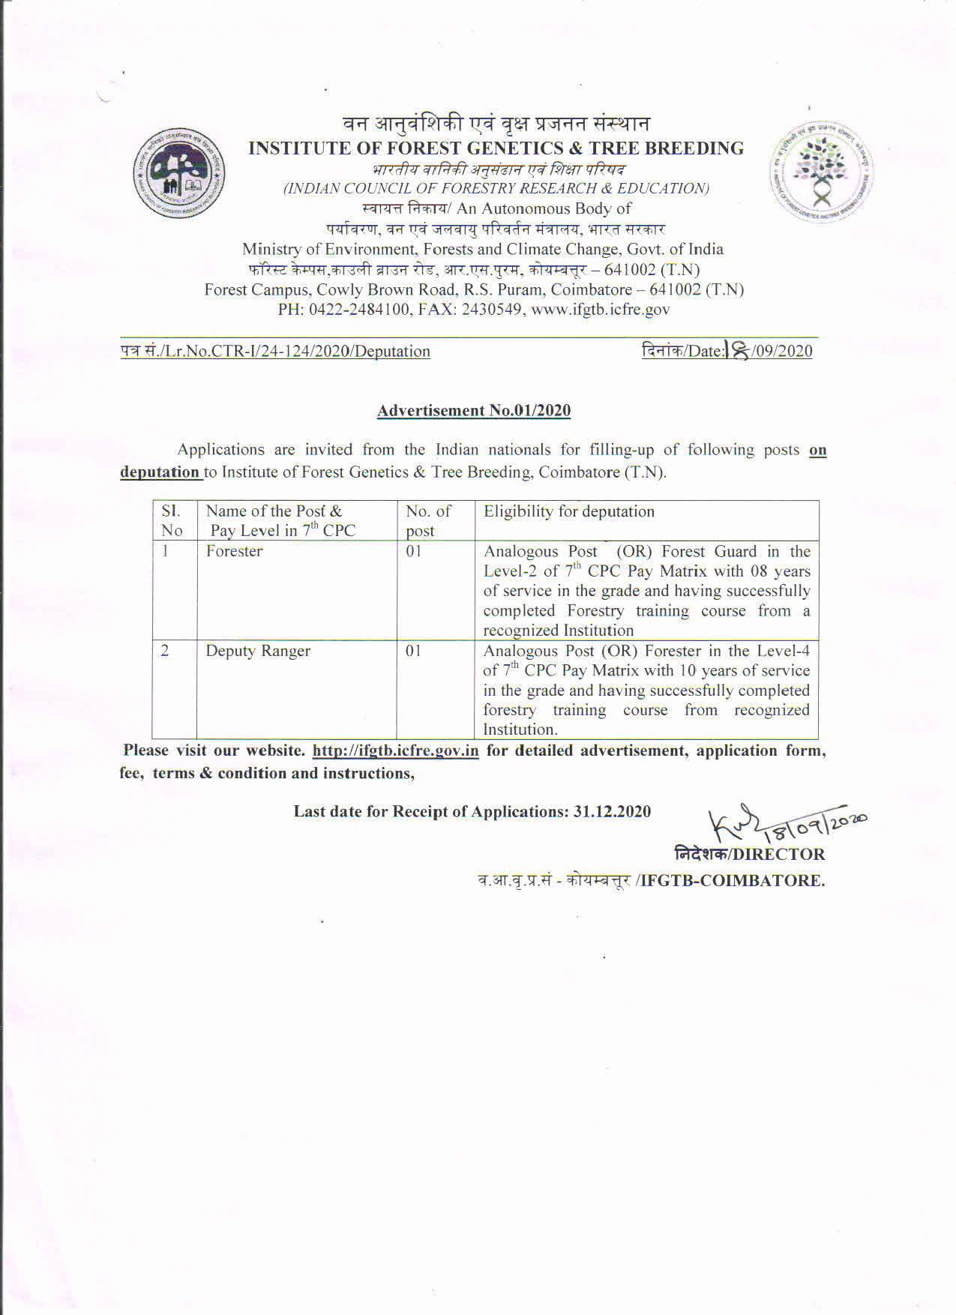

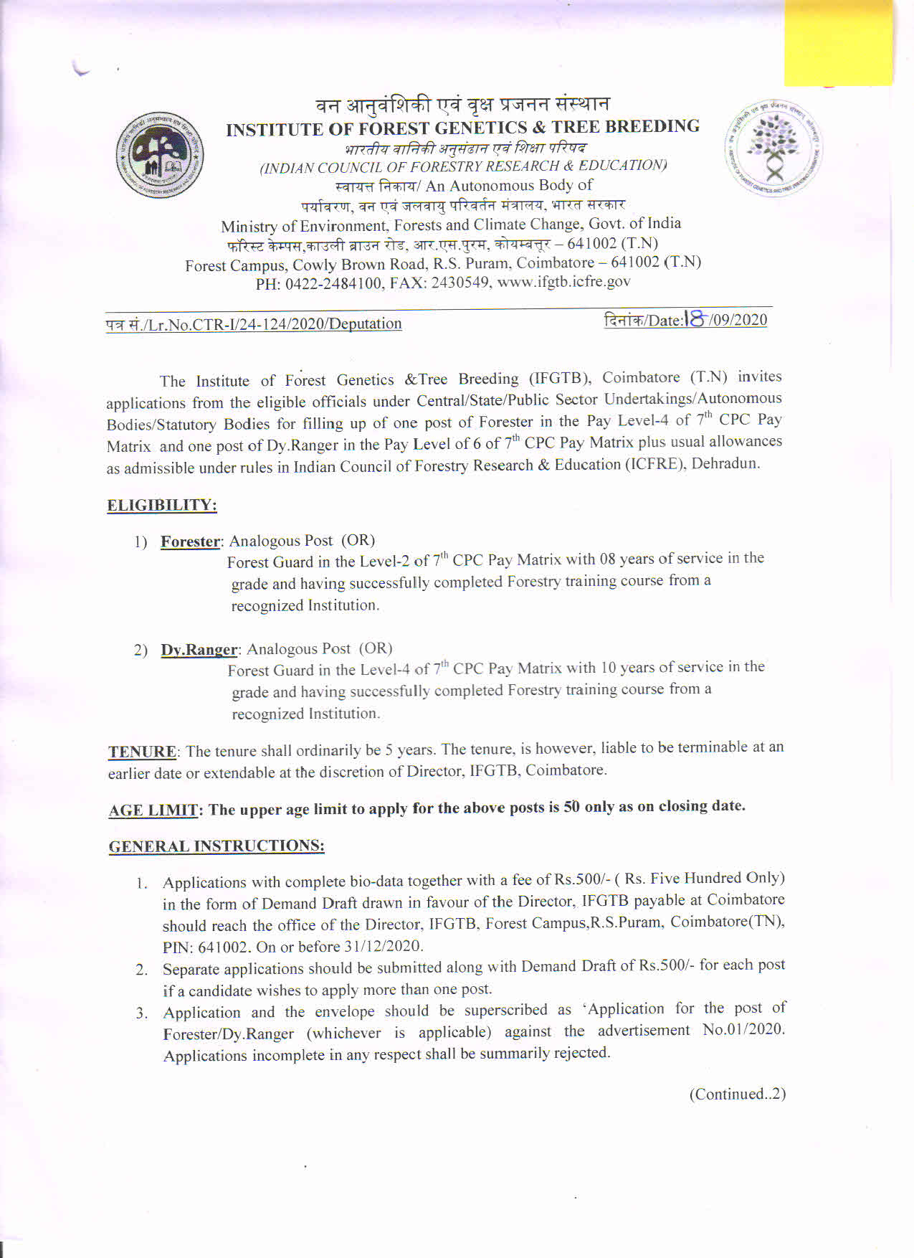

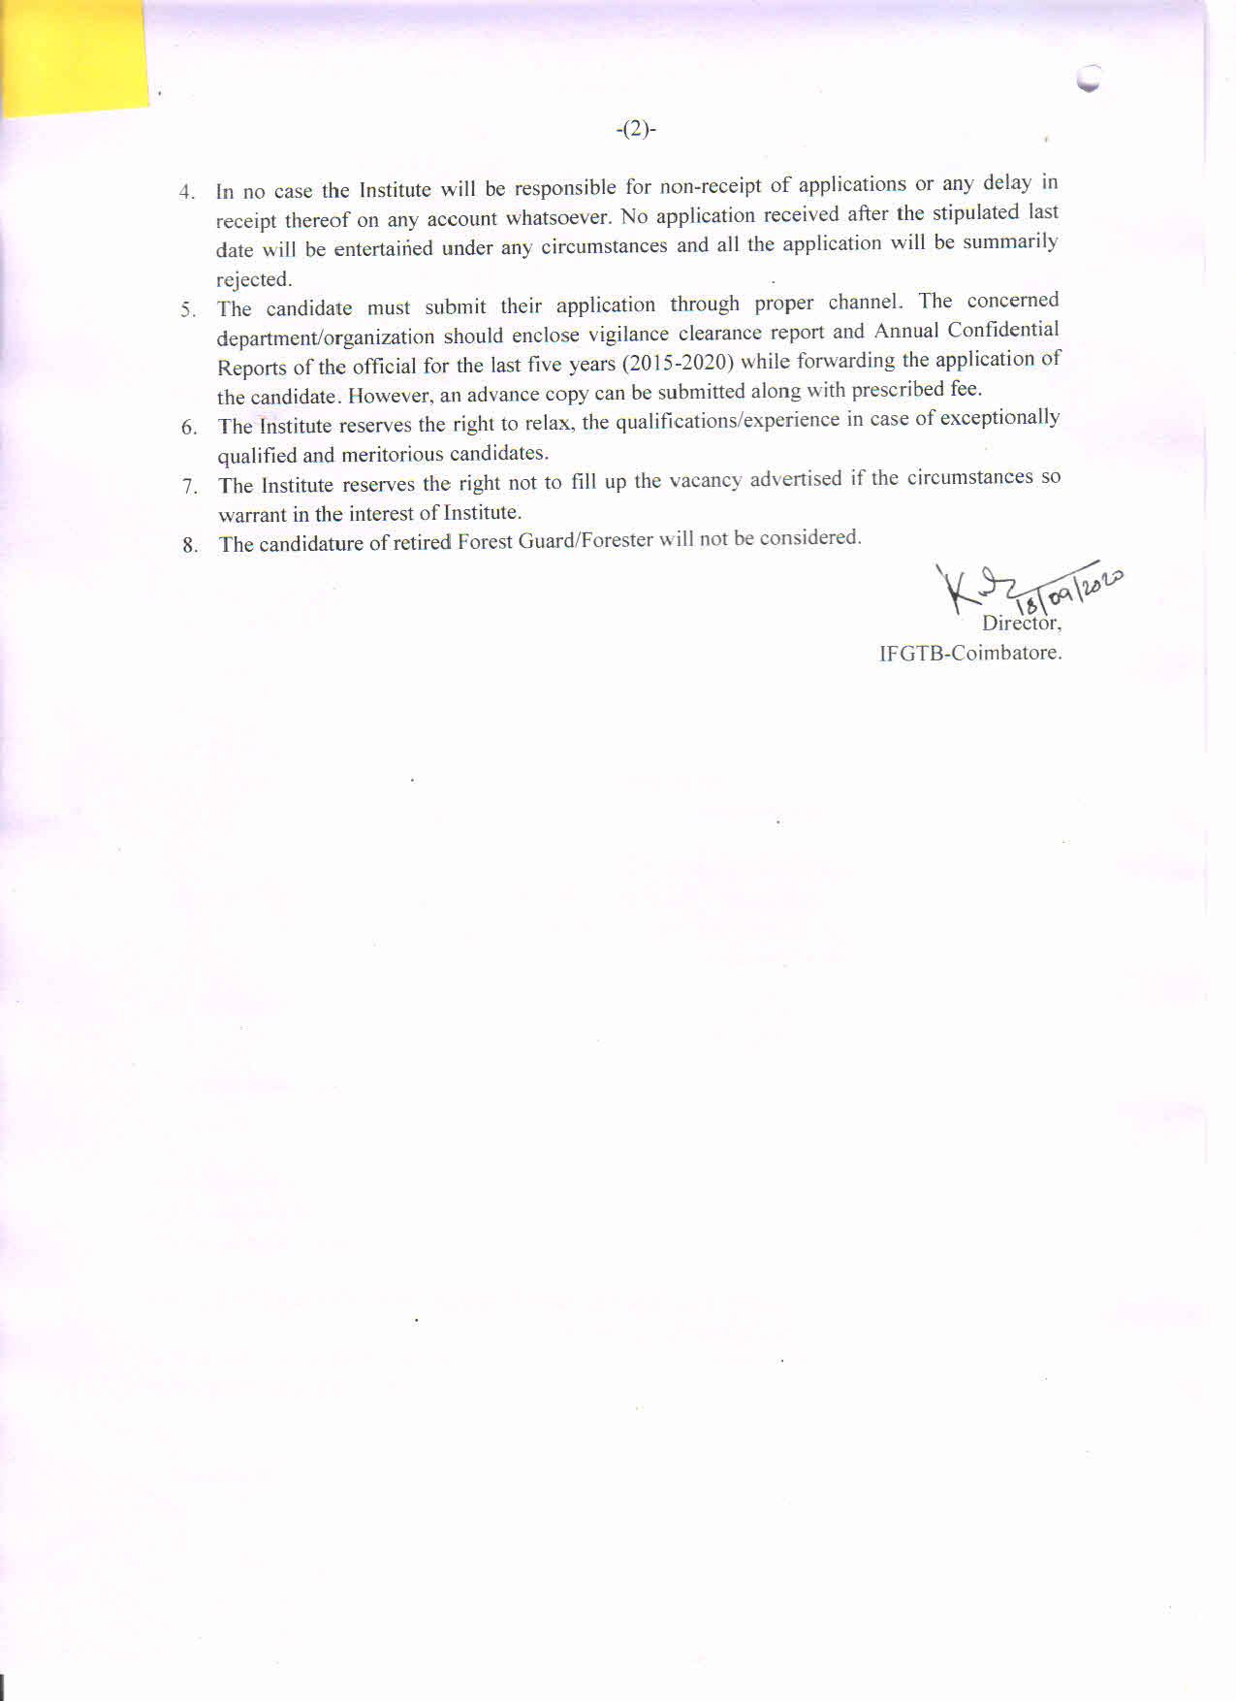

PROFORMA FOR APPLICATION FOR THE POST OF FORESTER

- Name (in Block Letter) :
- Date of appointment :
- Post currently held with pay scale :
- Date of Birth ( in Christian era) :
- Father’s/Husband’s Name :
- Address for correspondence :
( in block letters with pin code)
- Contact Number :
- E-mail ID :
- Educational Qualifications :

- Details of past service ( chronologically from present position backwards)

State | Forest Division | Post held  (with pay scale)
State | Forest Division | Post held  (with pay scale) | From | To

- Details of professional training course :
(Attached copy of Certificate)

- Date of retirement under the rules of
Central/State Government :

- Any other information :

- Bank Draft No. with date and amount:

Place: (Signature of the candidate)
Date:

PROFORMA FOR APPLICATION FOR THE POST OF DEPUTY RANGER

- Name (in Block Letter) :
- Date of appointment :
- Post currently held with pay scale :
- Date of Birth ( in Christian era) :
- Father’s/Husband’s Name :
- Address for correspondence :
( in block letters with pin code)
- Contact Number :
- E-mail ID :
- Educational Qualifications :

- Details of past service ( chronologically from present position backwards)

State | Forest Division | Post held  (with pay scale)
State | Forest Division | Post held  (with pay scale) | From | To

- Details of professional training course :
(Attached copy of Certificate)

- Date of retirement under the rules of
Central/State Government :

- Any other information :

- Bank Draft No. with date and amount:

Place: (Signature of the candidate)
Date:

Annexure

Certificate to be furnished by the Employer / Forwarding Authority certified that :
- The particulars furnished by Shri/Smt. ______________________________ are correct.

- There is no vigilance / disciplinary case either pending or contemplated against him/her.

- Integrity of the applicant is certified.

- Photocopies of the up-to-date ACRs, attested by an officer not below the rank of an Under Secretary to the Govt. of India are enclosed.

Date : (Signature of the Head of the Department /
Forwarding Authority)
Department/Office with seal
Telephone No._________________

